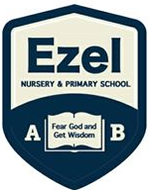 | EZEL NURSERY AND PRIMARY SCHOOL  Home Learning Program  www.ezelschool.com/homelearning.html
MIDDLE CLASS

Week 1
MONDAY
 | Topics | Activities
Math | - Counting Numbers  - Writing Numbers | - Count numbers from 1 to 10  - Write numbers 1 to 10
English | - Learn sight words and story words | - Sight Words: my , from , day , what  - Vocabulary: Fire, food , find , flower
Literacy | - Say out loud the letters, sounds and words | - Letters: A, B , C  - Say the sounds of letter A , B , C  - Say words that begin with letter A, B, C  Examples: apple, box , cat , cow
Recite the rhyme | Five little cats, Jumping on the bed.  One fell off and bumped his head.  Mother called the doctor, and the doctor said  No more cats jumping on the bed.
TUESDAY
 | Topics | Activities
Math | Practice counting shapes and numbers | - Count from 1 - 10  - Write the number 6 ten times  - Draw six squares
English | Learn sight words | - Sight words: Who, who , when  - Vocabulary: girl, grass, glass, green  Activity: Read the words and write the words
Literacy | Say out loud the letters, sounds and words | - letters A, B , C , D , E  - Say the sounds of letter A, B, C, D, E  - Say words that begin with letter A, B, C, D, E  Examples: dog, egg , duck , elephant
Five little cats, Jumping on the bed.
One fell off and bumped his head.
Mother called the doctor, and the doctor said
No more cats jumping on the bed.
WEDNESDAY
 | Topics | Activities
Math | Practice counting, shapes, numbers and patterns | - Count from 1 – 10  - Draw a Circle, square , oval and rectangle
English | Learn sight words | - Sight words: Who, who , when  - Vocabulary: girl, grass, glass, green  Activity: Read the words and write the words
Literacy | Practicing letter sounds | - letters A, B , C , D , E  - Say the sounds of letter A, B, C, D, E  - Say words that begin with letter A, B, C, D, E  Examples: doll, desk , elephant
Recite the rhyme | Five little cats
THURSDAY
 | Topics | Activities
Math | Practice counting, shapes, numbers and patterns | - Count from number 5 – 10  - Draw 7 ovals  - Write number 7 six times
English | Learning sight words and story words | - Sight Words: my , from , day , what  - Vocabulary: Fire, food , find , flower  Note: explain to the child the meaning of the words.
Literacy | Read the letter and words aloud | - Read letters D, E , F  - Say the sounds of letter D ,E , F  - Say words that begin with letter D , E, F  Examples: doctor, egg , fish, food, finger
Recite the rhyme | Five little cats jumping on the bed…
FRIDAY
 | Topics | Activities
Math | Practice counting, shapes, numbers and patterns | - Count from number 5 to 10  - Draw and count: 2 circles, 3 ovals, 4 squares, 5 triangles.
English | Learning sight words and story words | - Sight words: Who, who , when  - Vocabulary: girl, grass, glass, green  - Activity: Read the words and write the words
Literacy | Practice letter sounds | - Read letters D, E , F  - Say the sounds of letter D ,E , F  - Say words that begin with letter D , E, F  Examples: doctor, egg , fish, food, finger
Recite the rhyme | Five little cats, jumping on the bed…

Note: Dear parents/caregivers always make sure that
- You explain new words to your child.
- Recite new words as many times as you can
- Be kind and patient with your child, they cannot learn new things in one day.
- Provide your child with books, pencils, crayons and papers.

ACTIVITIES
Activity 1 (Language): Tracing the letters
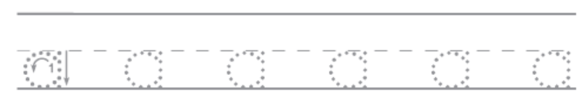
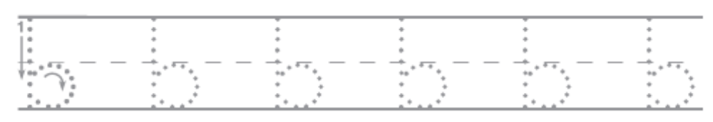

Activity 2 (environment): read the words and match them to the pictures
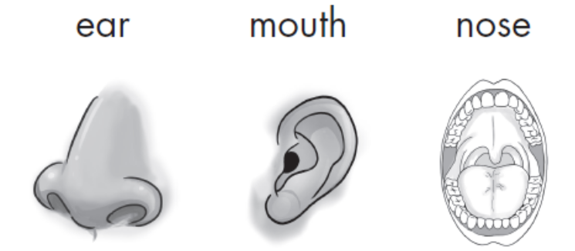
Activity 3 (Numbers): Trace  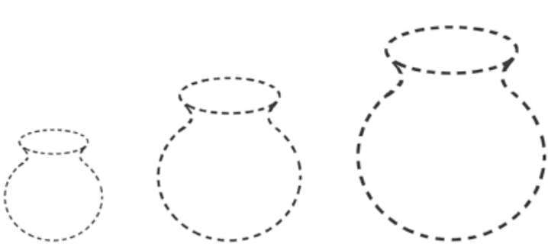 | Activity 4 (Environment) : Draw the following pictures.  - Nose  - Mouth  - Ear  - eye

Activity 5 (language): trace the letters
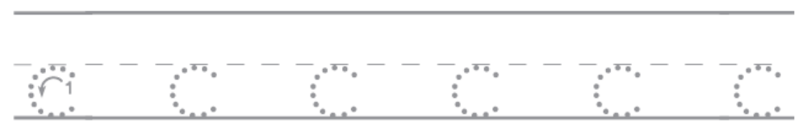
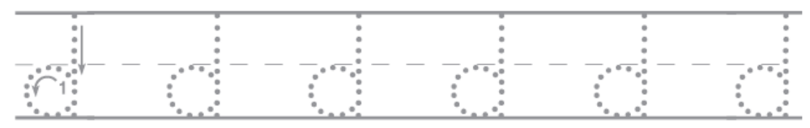
Activity 5: Match the word to the picture
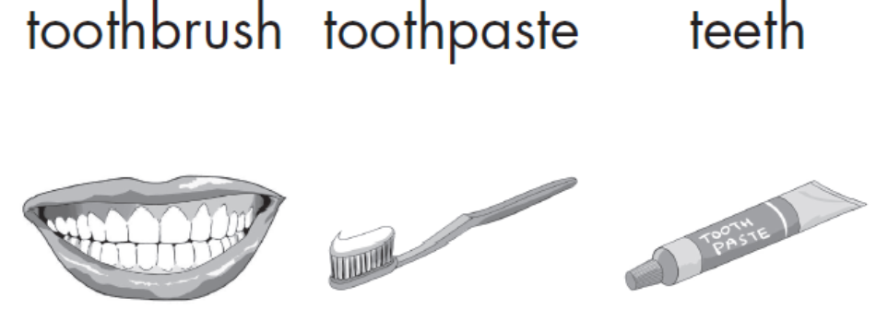

Activity 6 (Numbers): Count and write
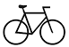 | =
 | =
 | =
 | =
 | =

Activity 7 (Language): Color the boxed that have capital letters
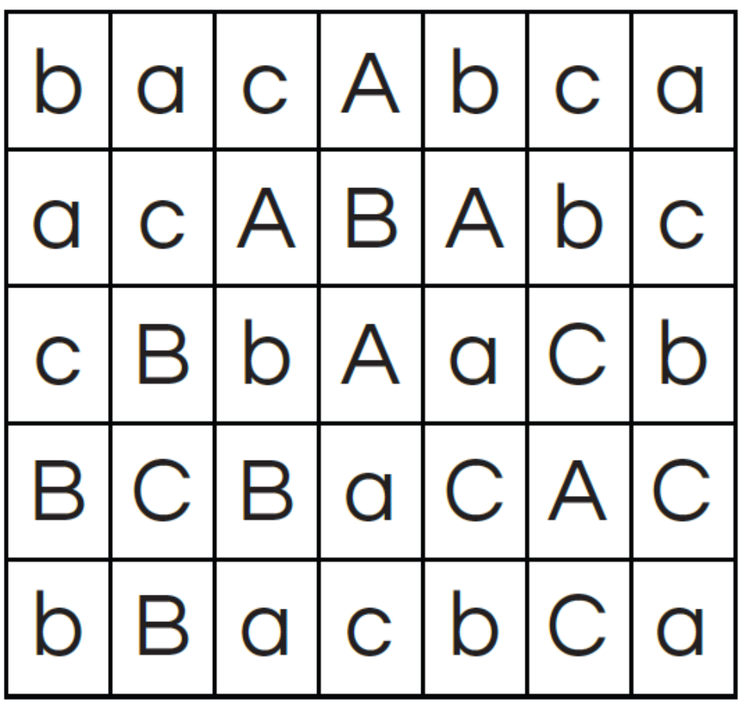
For more information, call:
Agule area and all other areas | Kameke Area
0772644523 | 0758650099 | 077074014 | 0786560989 [Director God Help Junior School]

